**CSE230 - Discrete Mathematics (Sec-7)**

Quiz #3

Total Marks: 20 Time: 40 minutes

**Please read the questions carefully before attempting to answer them.**

|  |  |
| --- | --- |
| **NAME:** | **ID:** |

1. For which  the 5𝑡ℎ expansion member equals ?  **[5]**

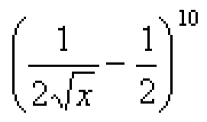

1. Find the coefficient of 𝑥5𝑦8 in (𝑥 + 𝑦)13 .  **[3]**

1. How many unique ways are there to arrange the letters in the word ENGINEERING? **[4]**

1. How many five-digit numbers can be formed from 1, 2, 3, 4, 5 (without repetition), when the digit at the unit’s place must be greater than that in the ten’s place? **[4]**

1. In a small village, there are 87 families, of which 52 families have at most 2 children. In a rural development program, 20 families are to be chosen for assistance, of which at least 18 families must have at most 2 children. In how many ways can the choice be made? **[4]**